|  |
| --- |
| BEAR PAW |
| Assembly Manual |

|  |
| --- |
| Name  Date |

Contents

1 Introduction 2

2 Naming & Definitions 2

2.1 Digits 2

2.2 Joints 3

2.3 Finger Part Naming Convention 4

3 Required Materials 5

3.1 3D Printed Parts 5

3.2 Ordered Parts 5

3.3 Tools 7

4 Assembly Flowchart 7

5 Material Preparation 1

5.1 3D Printed Parts (Insert # hours of Printing) 1

5.2 Potentiometers (Insert # of hours) 1

5.3 FSRs (Insert # of hours) 1

5.3.1 Fingertips 1

5.4 Screws (Insert # of hours) 1

6 Thumb Assembly 1

6.1 Part Assembly 1

6.2 Optional: Add.able Thumb Assembly 1

6.3 Mounting to Palm 1

7 Finger Assembly (Insert # of hours) 1

8 Servo Installation & Finger Tensioning (Insert # of hours) 1

9 GUI Software & Installation 1

9.1 Installation 1

9.2 1

Electronics 1

# 1. Introduction

While pediatric prosthetic devices are emerging on clinical and experimental horizons, researchers are missing a well-validated, robust device with open access to hardware and software. The straightforward and inexpensive Pediatric Assistive Ware designed at the UC Davis Bionic Engineering and Assistive Robotics Lab (BEAR PAW) provides an open-source platform to bridge this gap in knowledge. Dexterous, multiarticulate, and versatile in hand grasping patterns, the BEAR PAW will provide a platform for studies to better the understanding of how children will control prosthetics. Ultimately, enabling such studies will remove production and cost barriers to prosthetic device implementation in the pediatric market. Complete with materials, definitions, and pictorial instructions, this guide allows any interested individual or team to create the BEAR PAW.

# 2. Naming & Definitions

## 2.1 Digits

**D3**

**D3**

**D1**

**D2**

**D4**

**D5**

**D5**

**D1**

**D2**

**D4**

Figure 1: Standard digit numbering for left hand

## 2.2 Joints

Despite providing a negligible amount of flexibility, the distal joint in a child’s hand poses a manufacturing obstacle due to its requirement of precise micromotion. Thus, this design includes only two joints in each finger: the intermediate and proximal. The joints are called out in the following fashion: Digit-Position i.e. D3-I (Intermediate Joint on Digit 3). Note that is I is for Intermediate (joint farther away from the palm) and P for proximal (joint attaching the finger to the palm). The ability to rotate 90 into the page (assume palm down) is an additional degree of freedom provided to the thumb and this joint is called out as D1-R.

**D#-I**

**D#-P**

**D5-I**

**D5-P**

**D5-R**

**D4-I**

**D3-I**

**D2-I**

**D1-I**

**D5-R**

**D5-P**

**D3-P**

**D4-P**

**D5-I**

**D2-P**

**D1-P**

Figure 2: Joint Callouts

## 2.3 Finger Parts Naming Convention

**FORMAT: Hand-Digit-Phalanx-Position/Location in Phalanx-Identifying Information**

Hand: Right (R), Left (L), Uniformly applicable to either hand (U)

Digit: Since the parts and assemblies of D1, D2, D3 & D4 are identical, these are collectively called out as D1|4

Phalanx: Proximal (PPhal), Intermediate Phalanges (IPhal), Distal (DPhal)

Position/Location: If several parts make up a phalanx, they are referred to by location as being more proximal (closer to the palm) or distal (closer to the fingertip)

Identifying Information: Any other information (i.e. function) to distinguish parts

Note that Position/Location or Identifying Information are add-ons if necessary and may be left off the part name

Figure 3: Hand Bones

# 3. Required Materials

## 3.1 3D Printed Parts

*Table 1: Parts for 3D Printing*

--- Note About Uniformity of Finger Parts (2.3) ---

The parts and assemblies of D1, D2, D3 & D4 are identical, so the same finger essentially needs to be printed 4 times. Note that the fingertip (FT) mold only needs to be printed once and can be reused. The perception of fingers of varying length is achieved by the staggered positioning of the fingers on the palm assembly.

--- Note About Finger Part Naming (2.3)---

**FINGER PART FORMAT:** Hand-Digit-Phalanx-Position/Location in Phalanx-Identifying Information

Hand -- Right (R), Left (L), Uniformly applicable to either hand (U)

Digit – D1, D2, D3 & D4 are collectively called out as D1|4

Phalanx: Proximal (PPhal), Intermediate Phalanges (IPhal), Distal (DPhal)

Position/Location: If several parts make up a phalanx, they are referred to by location as being more proximal (closer to the palm) or distal (closer to the fingertip)

Identifying Information: Any other information (i.e. function) to distinguish parts

--- Note About Uniform Print Settings---

Hotend Nozzle is 0.4 mm and material is PLA, Global Layer 0.15 mm, Infill Density 25%, Speed 50 mm/s

Note: Supports advised when there is an extensive hole or overhanging arch; Or consider printing in a different orientation

Note: X 4 on the Finger Part Values to Account for All Fingers

|  |  |  |  |  |
| --- | --- | --- | --- | --- |
| **Part Name** | **Unique Print Settings** | **Print Length (meters)** | **Approximate Print Time** | **Part Mass** |
| L-D1|4-PPhal-PPart | None | 0.23 m | 26 min | 2 g |
| L-D1|4-PPhal-DPart | None | 0.21 m | 24 min | 2 g |
| L-D1|4-IPhal | None | 0.22 m | 26 min | 2 g |
| L-D1|4-DPhal | None | 0.12 m | 13 min | 1 g |
| L-D1|4-FTNeg1 | None | 1.00 m | 1 hr 16 min | 8 g |
| L-D1|4-FTNeg2 | None | 0.72 m | 51 min | 6 g |
| L-D1|4-Tensioner | None | 0.02 m | 3 min | ~ 0 g |
| L-D5-PPhal-PPart-PalmGear | Infill 50%  Global; 0.1 mm;  Using Supports Advisable | 1.33 m | 2 hr 50 min | 11 g |
| L-D5-PPhal-PPart-PalmDoor | None | 0.34m | 34 min | 3g |
| L-D5-PPhal-DPart | None | 0.29m | 28 min | 2 g |
| L-D5-IPhal-PPart | None | 0.24 m | 25 min | 2 g |
| L-D5-IPhal-DPart | None | 0.21 m | 20 min | 2 g |
| L-D5-DPhal-PPart | None | 0.15 m | 20 min | 1 g |
| L-D5-DPhal-DPart | None | 0.15 m | 15 min | 1 g |
| L-D5-PalmGearWheel | None | 0.08 m | 11 min | 1 g |
| L-D5-FTNeg1 | None | 0.98 m | 1 hr 17 min | 8 g |
| L-D5-FTNeg2 | None | 0.72 m | 53 min | 6 g |
| L-Palm-DorsalCover | Infill 35% Global; 0.12 mm; Use Supports | 2.63 m | 4 hrs 53 min | 21 g |
| L-Palm-InteriorFrame | Infill 35% Global; 0.1 mm; Use Supports | 2.75 m | 6 hrs 39 min | 22 g |
| L-Palm-PalmarCover | 0.12 mm; Use Supports | 1.67 m | 3 hrs 10 min | 13 g |
| L-Wrist-BaseMount | None | 2.56 m | 3 hrs 27 min | 20 g |
| L-Wrist-HandAdapter | None | 1.22 m | 1 hr 44 min | 10 g |
| L-Wrist-HandMount | None | 1.02 m | 1 hr 27 min | 8 g |
|  | **Totals:** | 0 m | 0 hr 0 min | 0 g |

## 3.2 Ordered Parts

The Table below contains all the necessary items to build a complete BEAR PAW. This table was finalized on 8/25/2022; therefore, some items may be discontinued or cost of items may change. The cost shown does not account for shipping/tax or any additional costs that may be incurred.

*Table 2: Parts for ordering*

|  |  |  |  |  |  |  |  |
| --- | --- | --- | --- | --- | --- | --- | --- |
| **Item** | **Description** | **Vendor** | **Part No.** | **Link** | **Qty.** | **Cost/Item** | **Ext. Cost** |
| **SENSORS/ELECTRONICS** | | | | | | | |
| KST X08N V5.0 | Micro Servo Motor with no mounting flanges | Alofthobbies | X08N | <https://alofthobbies.com/kst-x08n.html> | 1 | $46.00 | $46.00 |
| KST X08H V5.0 | Micro Servo Motor with top mounting flanges | Alofthobbies | X08H | <https://alofthobbies.com/kst-x08h-servo-2-8kg-38-oz-in-09-sec-8-grams-wide-voltage.html> | 1 | $46.00 | $46.00 |
| KST X08 V5.0 | Micro Servo Motor with side mounting flanges | Alofthobbies | X08 | <https://alofthobbies.com/kst-x08-servo-2-8kg-38-oz-in-09-sec-8-grams.html> | 4 | $46.00 | $184.00 |
| Breakout Board | 2 layer electronics breakout board, 17.8 x 33.0mm | OSHPARK | N/A | <https://docs.oshpark.com/services/two-layer/> | 1 | $5.00 | $5.00 |
| Solid State Relay | Omron, Solid State Relay - PCB Mount, 3 A, 60 V | Mouser Electronics | 653-G3VM-61AR1 | <https://www.mouser.com/ProductDetail/Omron-Electronics/G3VM-61AR1?qs=wnTfsH77Xs74FCx6Uqk9GQ%3D%3D> | 1 | $6.91 | $6.91 |
| Resistor | 5,600 Ohm Resistor, 5%, 0.5W Through Hole Resistor | DigiKey | S5.6KHCT-ND | <https://www.digikey.com/en/products/detail/stackpole-electronics-inc/CFM12JT5K60/1741974?s=N4IgTCBcDaIMIDECyBGMApAKgVgNIDYAGEAXQF8g> | 1 | $0.10 | $0.10 |
| Arduino Pro Mini 238 – 3.3V/ 8MHz | Micro Controller | Sparkfun | DEV-11114 | <https://www.sparkfun.com/products/11114> | 1 | $10.95 | $10.95 |
| FTDI Mini USB to TTL | Mini USB to TTL Adapter Board for Arduino | Amazon | B00IJXZQ7C | <https://www.amazon.com/HiLetgo-FT232RL-Converter-Adapter-Breakout/dp/B00IJXZQ7C/> | 1 | $6.99 | $6.99 |
| Bluetooth Module | DSD Tech HC-05 Bluetooth Serial Module | Amazon | B01G9KSAF6 | <https://www.amazon.com/DSD-TECH-HC-05-Pass-through-Communication/dp/B01G9KSAF6/> | 1 | $9.99 | $9.99 |
| Power Wires | 22 Gauge Silicone wire spool red 25ft and black 25ft Flexible 22 AWG Stranded Copper Wire | Amazon | B07HGT44XY | <https://www.amazon.com/BNTECHGO-Silicone-Flexible-Strands-Stranded/dp/B07HGT44XY/?th=1> | 1 | $9.98 | $9.98 |
| Connector Kit | 2.54 mm Crimp Pin Connector Housings, Single Row Male Headers, Male/Female Crimp Pins and Ribbon Cable | Amazon | ‎ B078RRPRQZ | <https://www.amazon.com/Dupont-Connector-Kit-Connectors-Plusivo/dp/B078RRPRQZ/> | 1 | $12.99 | $12.99 |
| Wall Adapter | AC/DC Wall Mount Adapter 5V, 20W | DigiKey | 102-4196-ND | <https://www.digikey.ca/en/products/detail/cui-inc/SWI25-5-N-P5/7070092> | 2 | $27.89 | $27.89 |
| Wall Jack | DC Barrel Jack Adapter - Female | Sparkfun | 10288 | <https://www.sparkfun.com/products/10288> | 2 | $3.50 | $3.50 |
| CENTAURUS Servo Tester STV2.3 | Steering Gear Rudder Detector Spare Parts for RC Aircraft Micro FPV DC 4.8V-6V | Amazon | B09LXTW19G | <https://www.amazon.com/CENTAURUS-Steering-Detector-Aircraft-4-8V-6V/dp/B09LXTW19G> | 1 | $3.50 | $3.50 |
| **HARDWARE AND MISCELLANOUS** | | | | | | | |
| Bearings | Bearing 2 mm Bore ID, 5 mm OD, 2.5mm | Amazon | B07X9T5F81 | <https://www.amazon.com/Donepart-MR52ZZ-Bearings-Miniature-Equipment/dp/B07X9T5F81> | 1 | $9.99 | $9.99 |
| Pulley for KST X08 Servo | Pulley for KST Servo Pack of 4 | Hyperflight | X08-PULLEY | <https://www.hyperflight.co.uk/products.asp?code=X08-PULLEY&name=pulley-for-kst-x08-servos-4> | 2 | $11.75 | $23.50 |
| Rotary Shaft 316 Stainless  Steel | 2 mm Shaft  200 mm long | McMaster Carr | 1265K17 | <https://www.mcmaster.com/1265K17/> | 1 | $14.27 | $14.27 |
| Torsion Spring | Torsion Spring 180 Degree Right-Hand Wound, 0.186'' OD  (Pack of 6) | McMaster Carr | 9271K665 | <https://www.mcmaster.com/9271K665/> | 2 | $5.19 | $10.38 |
| Strength Black Synthetic Cable | 0.75mm (0.03") in diameter, 5 m long, 45kg strength | ServoCity | 2908-0075-0005 | <https://www.servocity.com/synthetic-cable-black-0-75mm-diameter-5m-length/> | 1 | $2.99 | $2.99 |
| 18-8 Stainless Steel Screw | Narrow Cheese Head Slotted Screws M2 x 0.4mm Thread, 25mm Long (50 Pack) | McMaster Carr | 91800A023 | <https://www.mcmaster.com/91800A023/> | 1 | $10.15 | $10.15 |
| Heat Shrink Tubing Kit | Heat Shrink Tubing  (650 pcs) | Amazon | B07QM8249H | <https://www.amazon.com/625pcs-Shrink-Tubing-Tubes-Ratio/dp/B07QM8249H/> | 1 | $8.79 | $8.79 |
| Textured Rubber | Multipurpose Neoprene with Crisscross Texture Adhesive-Back Sheet, 12" x 12", 1/32" Thick | McMaster Carr | 8445K61 | <https://www.mcmaster.com/8445K61/> | 1 | $16.67 | $16.67 |
| **MATERIALS** | | | | | | | |
| Smooth-On Dragon Skin | 10 NV, 2 Pint Set (Moldable material for fingertips) | Reynolds Advanced Materials | MC-1244 | <https://www.reynoldsam.com/product/dragon-skin/> | 1 | $41.97 | $41.97 |
| Gorilla Super Glue Gel XL | 25 grams, clear | Amazon | B082XGL21J | <https://www.amazon.com/Gorilla-Super-Glue-transparente-102433/dp/B082XGL21J/> | 1 | $8.88 | $8.88 |
|  | | | | | | **Total** | $540­­­.21 |

**ADD NOTE OF BREAKOUT BOARD: Find Gerber file, upload to** *https://oshpark.com/*

## 3.3 Tools

* SigmaX R19 (3D Printer)
* Crimping Tool
* Sandpaper / Sanding Tool (Dremel)
* Screwdriver
* Wire Strippers
* Wire Cutter
* Tweezers
* Pliers
* Files
* Soldering Iron & Solder
* Knife
* Heat Gun

This section will fill out as you build the hand…

# 4. Assembly Flowchart

1. Print and prepare palm base
2. Insert servos into proper positions and prepare wires
   1. Prepare servos by cutting their wires to specified lengths and crimping the servo-end of the cut. Add the female adapter to each servo wire set.
   2. Solder the header pins (male adapter) to the other side of the cut wire
3. Finger assembly
   1. Proximal part assembly and mounting
   2. Distal part assembly and mounting
   3. Tendon laying and attachment to servo motors
   4. Finger tip preparation and mounting
4. Thumb Assembly
   1. File down thumb proximal proximal piece to house servo 6. Tendon laying
   2. Proximal part assembly and mounting (tendon laying continued)
   3. Intermediate part assembly and mounting (tendon laying continued)
   4. Distal part assembly and housing (tendon laying completion)
   5. Fingertip tip preparation and mounting

# 5. Material Preparation

## 5.1 3D Printed Parts & Cleaning Up (Insert # hours of Printing)

Note: Printed several parts in 1 G-code file to speed up the process

Sanding Parts in Order to Ensure Proper Fit:

-- Sanding Both Facets of a Joint to Ensure Comfort Fit 🡪 No gap, but minimal interference as to allow free sliding as at the joint connection of L-D1|4-PPhal-DPart & L-D1|4-IPhal

-- Sanding as to Allow L-D1|4-Tensioner to Sit Comfortably Inside the grooves in L-D1|4-IPhal

Sanding, Filing & Performing Deep Clean of Slits in L-Palm-DorsalCover after removing supports

Sanding/Filing to allow motors to fit & also for proximal finger parts to sit without interference

## 5.2 Potentiometers (Insert # of hours)

## 5.3 FSRs (Insert # of hours)

## 5.3.1 Fingertips

## 5.4 Screws (Insert # of hours)

# 6. Servo Installation & Wire Preparation (Insert # of hours)

## 6.1 Wiring Cut List

Each servo motor needs to be cut and have male/female ports added to the junction to allow for disconnection without disassembly. A diagram is supplied below that shows correlation of the servo’s to their respective functions.

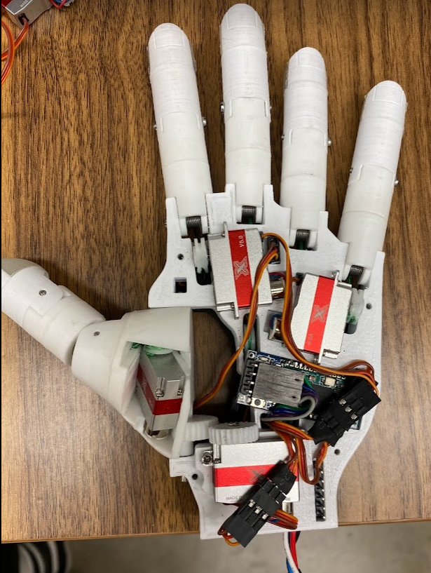

Motor 2: Middle finger (D3) flexion

Motor 1: Pointer finger (D2) flexion

Motor 4: Pinky finger (D5) flexion

Motor 6: Thumb (D1) flextion

Motor 3: Ring finger (D4) flexion

Motor 5: Thumb (D1) abduction

**Figure *blank*. Palmar side servo motor reference**

**Figure *blank*. Dorsal side servo motor reference**

**Table *blank*: Motor numbers and wire cut lengths**

|  |  |  |  |
| --- | --- | --- | --- |
| Motor Number | Servo Pin on Breakout PCB | Wire length from motor (mm) – Female end | Wire length from PCB (mm) – Male end |
| 1 | S4 | 80 | 70 (50?) |
| 2 | S3 | 50 | 100 (80?) |
| 3 | S2 | 40 | 110 (90?) |
| 4 | S1 | 60 | 90 (70?) |
| 5 | S5 | 65 | 85 (65?) |
| 6 | S6 | 95 | 100 |

**Numbering convention on the PCB breakout board is not the same numbering as the digits**

## 6.2 Wire Cut Procedure (Female End)

The cut list is designed to account for errors in cutting, so if done as specified above the system will have a slight amount of slack in the final assembly.

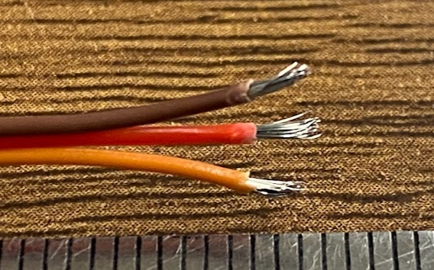 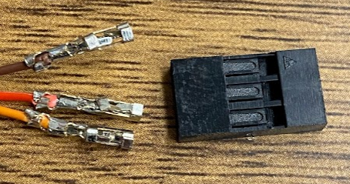

1. Cut the servo wires to the appropriate length given in the table above (**insert table number**).
2. Strip 2-3mm of insulation off each of the three wires to expose the proper amount of conductor. Twist conductor to prevent splaying, or “frizzing.”
3. Make sure each wire is separated 10mm to allow for ease in crimping.
4. Load a 10mm connector piece into the crimping device as shown (**image number**). Make sure the larger set of wings is flush with the surface of the crimping tool.
5. Insert one servo wire such that the first set of connector wings may anchor into the insulation of the wire and the second set of wings touches exposed conductor. Squeeze the device to the tightest setting and release.
6. Inspect the connector: lightly pull back and forth. If some movement occurs, use needle nose pliers to adjust the connection to make it more fit. Make sure the smaller wings are in good connection with the conductor.
7. Repeat connections for the remaining two wires.
8. Once all three connectors are attached, carefully insert all three connectors into a three-slot plastic housing receptable. Make sure all connectors are top-side up (should see a small square facing up on ­­­each connector).
9. Insert connectors into housing until you hear 3 clicks, one for each wire. Repeat for each wire of every servo motor.

## Wire Cut Procedure (Male End)

1. Remove the existing female-adapter and connector pieces off the three wires. Do this by cutting midway along the housing unit to break the plastic to expose the connector pieces at the end of each wire. Pull the connector pieces off using the pliers, exposing conductor.
2. Break off a set of 3 header pins using the pliers. Cut off three 10mm pieces of heat-shrink insulator and load onto each of the newly cut wire ends. Separate the wires, giving about 50mm of range between the soldering gun and the loaded heat shrink (to avoid premature shrinking.
3. Solder each wire to the shorter end of a header pin, and ensure the order of wires remains consistent (ie. Brown-red-orange). Once a connection has been made between two wires, load the heat-shrink insulator over the exposed conductor and apply a conservative amount of heat to the area (too much heat can melt the solder underneath and disrupt the connection).
4. Complete this process for male-ended wires 1-5. For wire 6, complete the same steps as listed above, however with a set of 3 right-angled header pins.h

# 7 Finger Assembly (Insert # of hours)

## 7.1 Part Assemble

Proximal Part (for D2-D5):

1. Sand and clean the flat ends of the two proximal pieces (‘S2|5-PPhal-DPart’ and ‘D1|4-PPhal-PPart’)
2. Glue the flat ends of the two pieces above together with the torsion slots on opposite sides (interior).

Distal Part (for D2-D5):

1. Sand and clean the flat faces of the distal (‘D1|4-DPhal’) and intermediate (‘D1|4-IPhal’) parts
2. Glue the flat faces of the two pieces above such that the round edge of the distal part is flush with the top side of the intermediate part.

## 7.2. Proximal Part

Proximal finger piece mounting:

1. Cut an M2X25 screw to 15mm thread length.
2. Insert torsion spring with the legs cut to an appropriate length (approximately 10 mm) into circular slot inside the proximal finger piece closer to the palm side:

1. Insert 15mm cut M2X25 screw through proximal joint, connecting the piece to the palm with the torsional spring keeping the piece in the outright (stretched) position.
2. Start with the middle finger, then continue to the ring finger, then pinky and then pointer finger.

## 7.3. Distal Part – *To be completed after section 8 below*

The mounting of the distal piece of the finger needs to be done in conjunction to the threading of the tendon from the tensioner to the servo. Because of this, this is the most intensive portion of the assembly procedure.

1. Servo pulley preparation (applicable for D2-5):
2. Attach a servo pulley to the servo arm such that the flat side of the pulley is facing away from the palm and the curved side is facing into the palm. Identify the hole in the pulley that is furthest from the distal finger joint and facing into the servo. We will call this hole the slotting hole.
3. Using a pointed-nose file, expand the slotting hole such that the tendon string can pass through with little fraying and resistance. Take care not to completely file away the exterior wall of the slotting hole. Filing of the surrounding features of the pulley may be necessary.
4. Tendon preparation (D2-5)
5. Position the tensioner within the distal piece such that it is slightly more proximal to the palm that its tracking allows. This will allow for maximum adjustment of tension within the finalized tendon.
6. Cut an M2X25 screw to 15mm thread length and temporarily attach the distal piece of each finger. Measure a length of synthetic cable from the tensioner to the servo pulley. To allow for error, give at least 60-80mm of extra string to the cut. Cut this length of string, careful to do so with as little fraying as possible.
7. Remove the tensioner from the distal piece. Insert the tendon string through to the distal-facing side and tie a simple knot to secure. There should be no more than 20 mm of string on the distal side of the tensioner.
8. Insert the tensioner back into the distal piece such that it is back to its position in step 1 and the knot is facing away from the palm.
9. Feed the proximal side of the tendons string through the appropriate palm slot if applicable. There should be a decent amount of extra tendon line past the motor.
10. Distal finger piece mounting (D2-5):
11. Now that the tendon is fed from the tensioner through the distal and proximal piece to the servo motor, the distal piece must be mounted to the proximal piece. Much like step 7.2.2, cut a torsion spring to approximately 10 mm and fit into the already mounted proximal piece.
12. Overlay the distal piece’s screw slots on that of the proximal piece such that the torsion spring’s opening is in line with the slots and the tendon string is on the interior side of the spring resting on the coiled portion.
13. While keeping the tendon string fixed over the coiled portion of the torsion spring, insert the cut M2X25 screw such that it passes through both piece slots and the torsion spring, holding everything together.
14. Test the finger’s bending movement once it is secure by pulling on the loose end of the finger until bending occurs. If no bending occurs, check to make sure the tendon string is laying over the coiled portions of the tension springs on each joint. The necessary torque cannot be applied if the string is not on the palm-side of the spring.
15. Tendon string mounting to servo pulley (D2-5):
16. Slot the tendon string through the slotting hole of the servo pulley such that the string passes over the pulley’s track. When the pulley is lined up to be mounted to its servo, the string should be in the gap between the pulley and the servo.
17. Measure the minimal tendon length needed for the tendon to connect the tensioner and the servo once the pulley would be mounted. Add 10-15mm to that length and carefully cut off the excess string.
18. Using a lighter or compact fire source, burn the 10-15mm of excess string down to stick to the pulley.
19. Mount the pulley to the servo arm. Using the servo tester, bend the finger. If a large amount of slack is in the initial bend of the finger, remove the pulley and remount it in a configuration that has more slack. If a small amount of slack is present, tighten the tensioner via the flathead screw on the tip of the finger. Adjust until optimal tension is acquired.

# 

# 8. Thumb Assembly

## 8.1 Part Assembly / Preparation

1. File/clean flat faces of *D1-PPhal-DPart* and *D1-PPhal-PPart-PalmGear*. Glue the two together in the orientation shown in **Figure __** to the right.

Note: attempt to line up the screw opening diagonal of the closest corner of the rectangular opening on *D1-PPhal-PPart-PalmGear*. (See visual on Solidworks assembly file.

Ensure the hole on the flat face of the proximal piece is through to the interior cavity, as the tendon string will pass through this hole. The proper hole pathway can be seen in the Solidworks model provided.

2. File/clean flat faces of *D1-IPhal-DPart* and *D1-IPhal-PPart* and glue them together such that the interior slots meant for the torsion springs are on opposite sides as shown in **Figure __** to the left. Complete the same process for *D1-DPhal-DPart* and *D1-DPhal-PPart* (**Figure __** to the right).

3. Test the friction between the pieces of each joint (*D1-PPhal-DPart* with *D1-IPhal-PPart*, and *D1-IPhal-DPart* with *D1-DPhal-PPart*) and sand away any necessary interference such that smooth rotation can occur.

4. Cut and file the end of three M2X25 screws; one should be 21mm (proximal joint), the other two should be 18mm (distal joint and tensioner screw).

5. Prepare the tendon string by cutting a 150mm piece. The actual functional length of the string once completed and assembled is only about 60mm, but excess allows for error to be corrected.

6. Two servo motors belong to the thumb assembly. The first is for thumb abduction (servo 5) and the second is for thumb flexion (servo 6). Servo 5 mounts to the anterior side of the palm towards the wrist, and servo 6 within the *D1-PPhal-PPart-PalmGear* piece (see **Figure __**). Prepare a servo pulley for servo 6, and mount the *D1-PalmGearWheel* piece to servo 5.

## Thumb Assembly

## 8.3 Mounting to Palm

1. Begin with the *D1-PPhal-PPart-PalmGear*. Feed the tendon string through the hole on the flat face of the part. The string side that is exiting the flat face-side of the hole will be referred to as the “distal side” of the string, and the string side exiting through the internal opening will be referred to as the “proximal side” of the string.

2. The slack end of the string will be the distal side. This means that the servo pulley (from within the *D1-PPhal-PPart-PalmGear*) will be the taut end of the string while working, and excess string will be fed through the proximal, then the intermediate and finally the distal thumb pieces.

3. Prepare the servo according to the image (add image of how the servo fits here). Sand any of the internal faces of the PalmGear part in order to allow a tight fit of the servo. Insert the string for the pulley through the distal end & then secure the pulley to the string after the string has come out of the proximal side. The pulley can then be secured to the servo.

4. Ensure that the servo wires are exiting the PalmGear part through the appropriate slot (Picture here).

5. Mount the proximal piece using the cut rod

# 8. Servo Installation & Finger Tensioning (Insert # of hours)

## 8.1 Wiring Cut List

Each servo motor needs to be cut and have male/female ports added to the junction to allow for disconnection without disassembly. A diagram is supplied below that shows correlation of the servo’s to their respective functions.

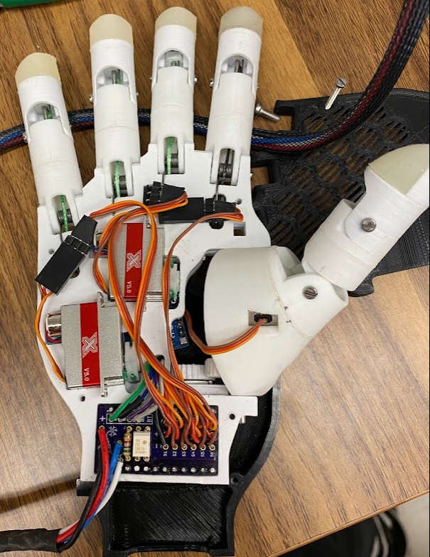

Motor 2: Middle finger (D3) flexion

Motor 1: Pointer finger (D2) flexion

Motor 4: Pinky finger (D5) flexion

Motor 6: Thumb (D1) flextion

Motor 3: Ring finger (D4) flexion

Motor 5: Thumb (D1) abduction

**Figure *blank*. Palmar side servo motor reference**

**Figure *blank*. Dorsal side servo motor reference**

**Table *blank*: Motor numbers and wire cut lengths**

|  |  |  |  |
| --- | --- | --- | --- |
| Motor Number | Servo Pin on Breakout PCB | Wire length from motor (mm) | Wire length to end (mm) |
| 1 | S4 | 80 | 70 (50?) |
| 2 | S3 | 50 | 100 (80?) |
| 3 | S2 | 40 | 110 (90?) |
| 4 | S1 | 60 | 90 (70?) |
| 5 | S5 | 65 | 85 (65?) |
| 6 | S6 | 95 | 100 |

## 8.2 Wire Cut Procedure

The cut list is designed to account for errors in cutting, so if done as specified above the system will have a slight amount of slack in the final assembly.

  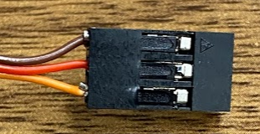

1. Cut the servo wires to the appropriate length given in the table above (**insert table number**).
2. Strip 2-3mm of insulation off each of the three wires to expose the proper amount of conductor. Twist conductor to prevent splaying, or “frizzing.”
3. Make sure each wire is separated 10mm to allow for ease in crimping.
4. Load a 10mm connector piece into the crimping device as shown (**image number**). Make sure the larger set of wings is flush with the surface of the crimping tool.
5. Insert one servo wire such that the first set of connector wings may anchor into the insulation of the wire and the second set of wings touches exposed conductor. Squeeze the device to the tightest setting and release.
6. Inspect the connector: lightly pull back and forth. If some movement occurs, use needle nose pliers to adjust the connection to make it more fit. Make sure the smaller wings are in good connection with the conductor.
7. Repeat connections for the remaining two wires.
8. Once all three connectors are attached, carefully insert all three connectors into a three-slot plastic housing receptable. Make sure all connectors are top-side up (should see a small square facing up on ­­­each connector).
9. Insert connectors into housing until you hear 3 clicks, one for each wire. Repeat for each wire of every servo motor.

# 9 GUI Software & Installation

## 9.1 Installation

## 9.2

# Electronics